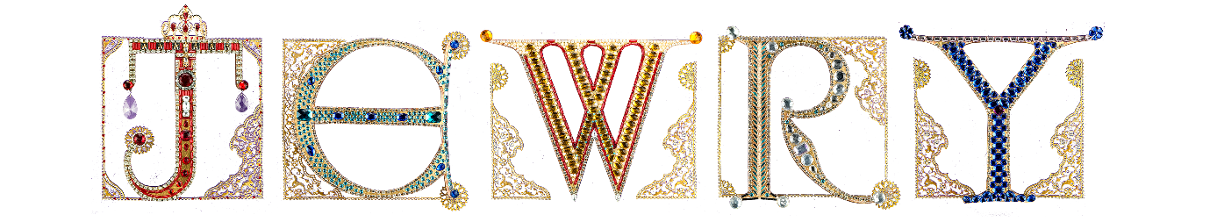

Christmas Cocktails

Pomegranate Rosemary Spritzer

Cranberry Apple Moscow Mule

Elderflower Bright Star

Mojito

£9

Wine
Red
2014 Berry Bros. & Rudd Good Ordinary Clare
White
Berry Bros. & Rudd Pinot Grigio delle Venezie by Nec Otium, Friuli
Rose
Berry Bros. & Rudd Reserve Rose by Collovray & Terrier

Sparkling Wine
£7
Beers
Peroni, Heineken
£5

Soft Drinks
Cranberry, Apple, Orange, Pineapple
£4
Coke, Lemonade, Tonic, Elderflower, Ginger ale
£4.50

