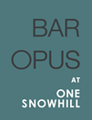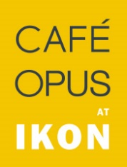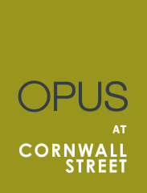

SPRING SUMMER BOWL FOOD (April – September)
£12 for 2 bowls per person

Bowl Food is a walking buffet! These are mini meals served in individual, small bowls.
Choose 2 or 3 from the following list which will be available for your guests at the event:

Cotswold white chicken and bacon Caesar salad
Gem lettuce and parmesan

Spiced masala vegetables (v)
Coconut rice and coriander

Lamb cutlet
Champ mash, parsley salsa

Fillet of monkfish
Vegetable couscous, salsa verde

Baby mozzarella and heritage tomato (v)
Homemade pesto and balsamic dressing

Breaded plaice goujons
Chips and tartare sauce

All prices include VAT at standard rate.

Please discuss any dietary requirements or allergies.

Minimum numbers:
Bar 40pax
Café 40pax
Restaurant 50pax

