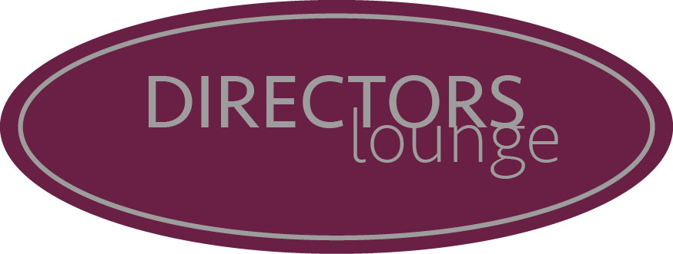

BOOKING TERMS AND CONDITIONS
To secure your reception, complete and return the Booking Form, together with a deposit of 50% of your minimum spend.
Sending us your booking form doesn’t confirm your date, until your deposit has been taken and confirmed to you by one of our Events Team.
Ahead of your event the Events Team will create your Event Plan, tailored to your requirements. This plan will outline your anticipated charges as well as important details for your day.

Final Payment
Full payment of the pre-ordered food and drink and will be detailed on the plan, and any other known costs must be settled 14 days prior to the event.
We require credit card details to be given as guarantee for all other expenses incurred on the day. If the full amount is not settled on the day of the event by any other cardholder, the outstanding balance will be charged to the card whose details we hold as a guarantor.
Prices and products are only guaranteed upon full payment and may be subject to change at any time.
1. All bookings will be confirmed by Director’s Lounge ( DL) upon receipt of the booking form & deposit.
2. An Event Plan tailored to your requirements will be created. This plan will outline your anticipated charges.
3. Final payment as set out in the Event Plan must be made no later than 14 days prior to the reception.
4. You will need to finalise reception details no later than 14 days prior to the event. The numbers of guests will be set at this time.
5. Food and beverage prices are inclusive of VAT, but exclusive of a 12.5% service charge. This will be discussed with hirer.
6. Your card details will be held against cancellation, any outstanding balance, should your event not reach minimum spend and damages. If there are no charges outstanding after the event your card will not be debited with any additional costs
7. Prices/products are only guaranteed upon full payment and are subject to change at any time.
8. DL shall not be held responsible for loss or damage to any property or injury during hiring of the facilities arising from any cause whatsoever.
9. The hirer shall be responsible for insuring all their own equipment brought into the premises and for any damage caused to any DL property or fixtures by any person, equipment or exhibits brought onto the premises by the hirer or their guests.
10. DL reserve the right of admission to any disruptive individuals
11. The hirer shall be responsible for paying for all charges arising from the booking including the cancellation fee.
12. The hirer and his/her guests must adhere to our H & Safety policy at all times during the Event.
13. Smoking is not permitted on the DL premises.

