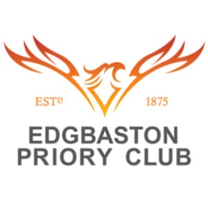

EDGBASTON PRIORY CONFERNECE & EVENTS
CONFERENCE BUFFET OPTIONS

CONFERENCE BUFFET LUNCH 1
SELECTION OF CLOSED SANDWICHES & WRAPS
CHEFS SELECTION OF OPEN SANDWICHES
HOME MADE NACHOS
FRUIT PLATTER
£7.95

***
CONFERENCE BUFFET LUNCH 2
SELECTION OF OPEN & CLOSED SANDWICHES &WRAPS
CHEFS CHOICE OF SALADS WITH DRESSINGS & DIPS
SALMON & COD FISH CAKES
MEDITTERIAN VEGATABLE & GOATSCHEESE TARTS
SELECTIONS OF PIZZA FLATBREADS
SAUSAGE ROLLS OR PORK PIES
HONEY MUSTARD GLAZED MINI SAUSAGE ROLLS
HAM CROUQUETTES
MINI CROQUE MONSIEU/MADAME ROYAL
BBQ CHICKEN WINGS
MAXIMIUM OF 4 ITEMS TO BE CHOOSEN
£11.25

DESSERT
SELECTION OF CAKES,MUFFINS AND PASTRIES
INDIVIDUAL LEMON TARTS
CHOCOLATE BROWNIES

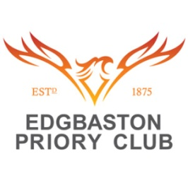

CONFERENCE FORK BUFFETS
SLOW BRAISED BEEF GOULASH WITH NEW POTATOES & SEASONAL VEG
CHICKEN CHASSEUR WITH ROAST POTATOS & ROOT VEG
BEEF LASAGNE WITH GARLIC CIABATTA & SALAD
THAI GREEN CHICKEN CURRY WITH STEAMED RICE & NAAN BREAD
SALMON & COD FISH CAKES WITH WHITE WINE SAUCE
FISHERMANS PIE TOPPED WITH MASH POTATOES AND MIXED GREENS
SWEET & SOUR STIR FRY SERVED WITH GREENS & BEAN SPROUTS
ADD TIGER PRAWNS FOR £2
1 Course: £11.95
2 Course: £13.00

DESSERTS
STICKY TOFFEE PUDDING WITH TOFFEE SAUCE
APPLE AND CINNAMON CRUMBLE WITH FRESH CUSTARD
SELECTION OF FRUIT CHEESE CAKES
THE FOLLOWING MENU HAS A CHOICE OF ONE OR TWO COURSES. A MAXIMUM OF THREE MAINS AND TWO DESSERTS

KIDS MENU
SELECTION OF SANDWICHES & WRAPS
CRUDITIES WITH A SELECTION OF DIPS
CHIPS OR FRIES
NACHOS
£6.50

HOT MENU
FISH BITES WITH CHUNKY CHIPS PEAS OR BEANS
CHCIKEN GOUJONS WITH CHUNKY CHIPS PEAS OR BEANS
KIDS SLIDER BURGER WITH CHUNKY CHIPS PEAS OR BEANS
TOMATO AND CHEESE PASTA
CHEESE & TOMATO CIABATTA PIZZA
£7.95

CHOICE OF DESSERT
FRUIT POT
SWEET TREAT
CHOCOLATE SURPRISE

