Welcome,

The Worshipful Company of Furniture Makers’ is delighted to welcome you to our beautiful Hall in the heart of the City of London.

The impressive listed building in Austin Friars, a lovely little cul-de-sac behind Throgmorton Street, was acquired by The Worshipful Company of Furniture Makers’ in April 2008. The Furniture Makers’ are only the fourth Livery Company to acquire its first Hall since the Apothecaries in 1632.

If you have any specific requirements please do not hesitate to share these with us and we will be delighted to assist you.

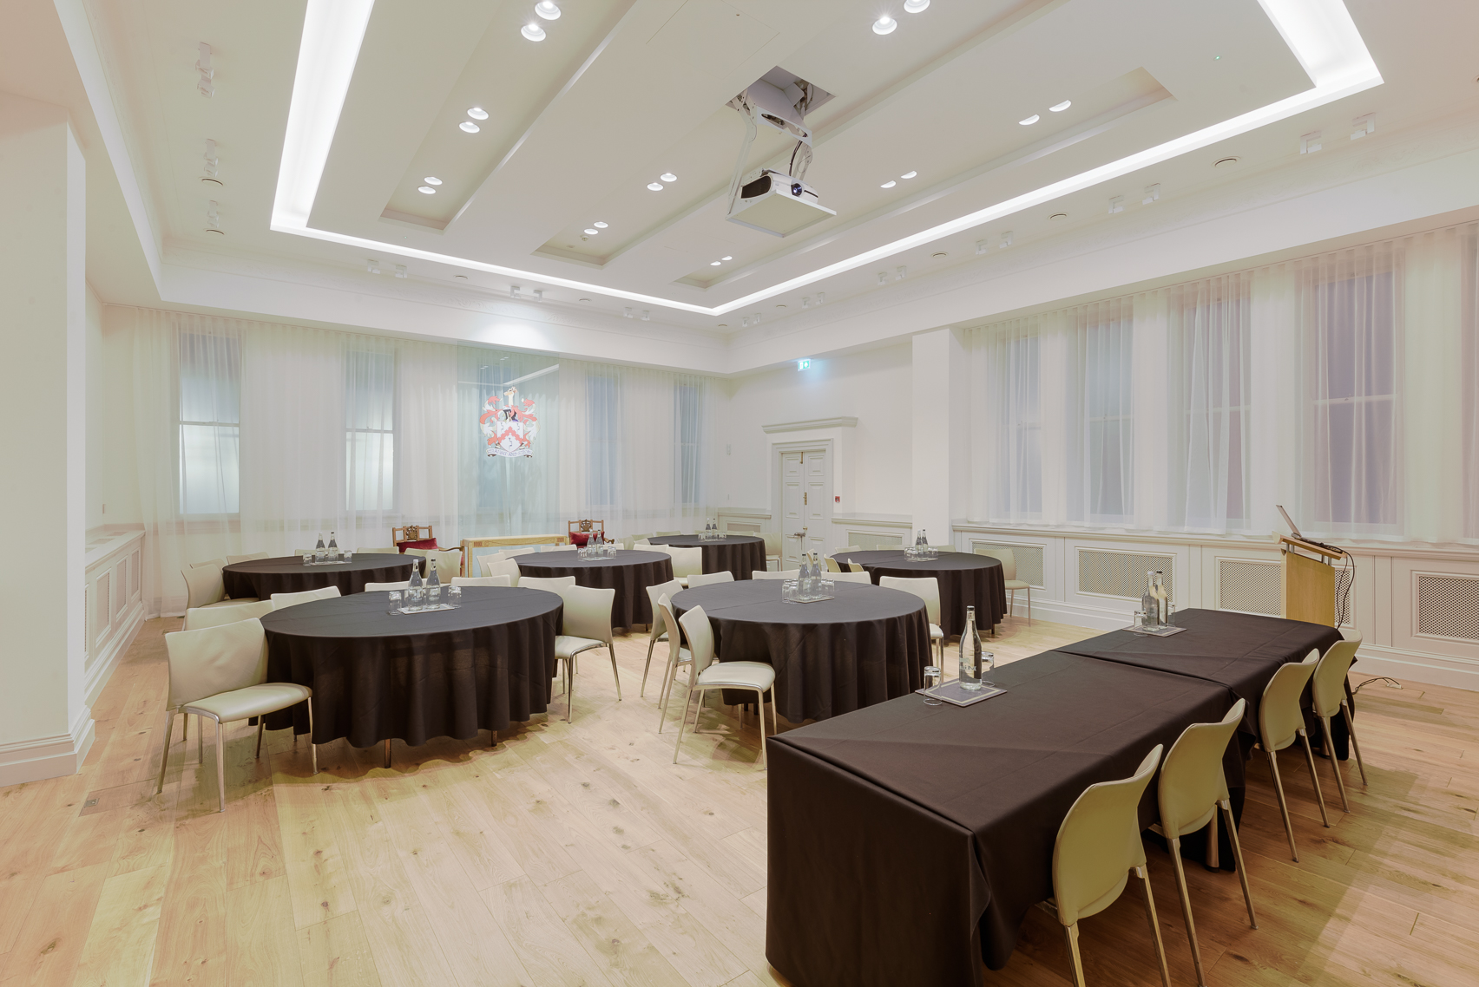

DDR Package* £65.00 + VAT per person

Based on a minimum of 8 delegates

PACKAGE INCLUDES:
Room hire, data-projector, screen and flipchart.
All rooms have natural daylight, Wi-Fi and air conditioning.

MORNING – ON ARRIVAL
Italian roast coffee and decaffeinated blends (free-flow)
Fruit, herbal and black tea (free-flow)
Jugs of water
Finger pastries
Bacon rolls (supplement of £5.00 per person)

MID-MORNING BREAK
Italian roast coffee and decaffeinated blends (free-flow)
Fruit, herbal and black tea (free-flow)
Jugs of water
Sweet and wholegrain biscuits

WORKING LUNCH
One and half rounds of sandwiches
Fresh cut fruit platter
Crisps
Cheeseboard or Soup
Mini cakes
Jugs of water
Jugs of fruit juice
Hot Fork Buffet for a supplement of £7 per person (minimum 25 delegates)

AFTERNOON BREAK
Italian roast coffee and decaffeinated blends (free-flow)
Fruit, herbal and black tea (free-flow)
Jugs of water
Afternoon tea cakes

*Available in the Arnold Moore Room, the Mike Clare Room and the David Burbidge Suite for 8 – 120 delegates from 9.00am – 5.00pm, subject to promotional availability and room allocation dependent on final numbers. Upgrade to a Hot Fork Buffet for a supplement of £7 per person (minimum 25 delegates). All rates exclude VAT and are valid until 22/12/2016. Furniture Makers’ Hall, 12 Austin Friars, London, EC2N 2HE

Room Capacity

 | David Burbidge Room (Ground Floor) | Arnold Moore Room (Ground Floor) | Mike Clare Room (1st Floor)
Conferences and Meetings
Theatre | 120 | 15 | 25
Classroom | N/A | N/A | N/A
U-shape | 33 | N/A | N/A
Boardroom | 30 | 10 | 16
Banquets and Dining
Banqueting Rounds | 80 | N/A | 20
Sprigs with tabletops | 84 | N/A | N/A
Reception | 120 | 20 | 30
One long table | 30 | 10 | 16

